# Working with Image Files

## Lab Objectives

1. Using a Picture Box
2. Working with the Open File Dialog control

## Working with Image files

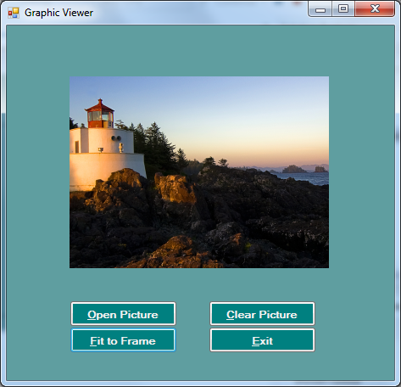

We can allow the user to select files from different drives and folders using the OpenFileDialog control.

In this chapter we will create the form shown below which allows a graphic image to be selected from a specific drive and folder, and then displayed on the screen.

The OpenFileDialog will also restrict user file selection to png, bmp, and jpg files. If one of these is selected then the graphic will be displayed.

1. Open a New Project to begin.
2. 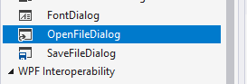Add an OpenFileDialog control to anywhere on the form from the Dialogs section of the toolbox.
3. Name the OpenFileDialog with the suffix **ofdSelectImage**

## The Picture Box Control

A Picture box is a control which allows various types of images to be displayed.

1. Click on the Picture box control in the tool box.
2. Click and drag the Picture Box onto your form.
3. Change the Name property of the picture box to **pbxGraphic**.

## Adding the buttons

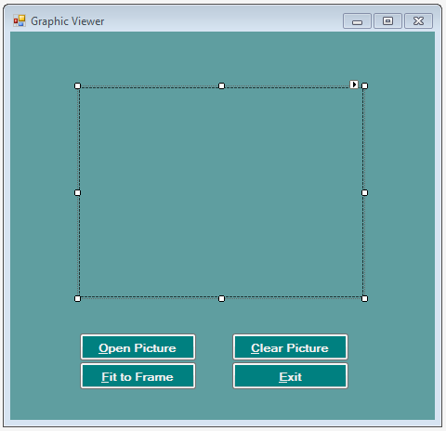Add the following buttons, setting their Name and Text properties as follows:

**Control Text**

btnOpenPicture &Open Picture

btnClearPicture &Clear Picture

btnFitFrame &Fit to Frame

btnExit &Exit

## Writing the code

The next step is to write the code which will display the Open File Dialog box. This will allow the user to select a file and then display it in the Picture Box.

1. Double click on the **Open Picture** button to display the code window.
2. Enter the code shown below. (The Private Sub and End Sub lines have been left out)

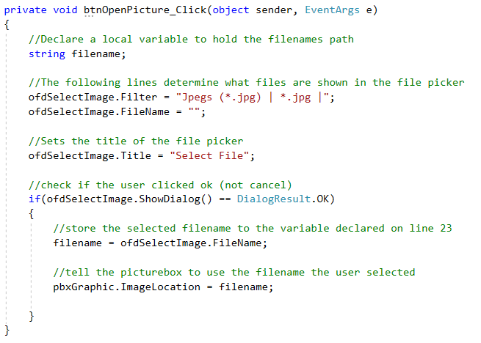

1. Double click on the **Clear Picture** button to create the click event for that button
2. Enter the code shown below

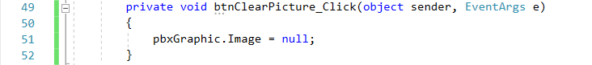

1. Double click on the **Fit to Frame** button to generate the click event for that button
2. Enter the code shown below

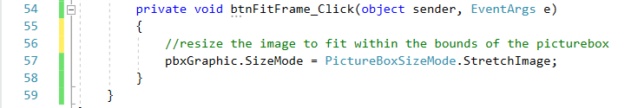

## Running the application

1. Run the application by press f5 on your keyboard
2. An image file should display when selected through the Open File Dialog box.
3. Click on the stop button on the tool bar to return to Visual Studio.

## problem decomposition diagram

A problem decomposition diagram provides a basic overview of the requirements of the program:

# Project

In this exercise you will modify the existing program to allow for the display of four graphic images on the screen at the one time. If the Clear button is pushed then all the images are cleared.

1. Ensure each of the picture boxes display the picture at an appropriate size (SizeMode property– StretchImage). You can do this in the designer or in code on the load method
2. Add the menu, and relevant code as displayed.

## Research Exercise

Exit with an interactive dialog when the user clicks the exit button i.e. “Are you sure you want to Exit?” message box

You can get the result of a message box in a similar way to getting the file from an OpenFileDialog.  
  
See if you can find out how to use an interactive **MessageBox** in Windows Forms C#

Work with a partner and search online for a code snippet that will help you do this. If you find the answer, share it with someone else too.